

Summative Assessment (SA)

Submitted BY
DEVANSHU JAIN
(Enrol. No.: 20220701005)

Course Code and Title: Machine learning

B.Sc. (Hons.) Computer Science / Data Science / AIML

III Semester – July – Nov 2023

UIT
Dec/apr 2024

Index:

- What is chatbot?

- Hoes does machine learning helps to create a chatbot?

- Cafebot:

- Building a Cafebot using Machine Learning:

- Codes:

- machine learning algorithms used in chatbot:

- Answers:

Interactive ai chatbot: develop an ai chatbot that can engage in natural language conversations with users, providing information, answering questions, or assisting with tasks using ml1. Capabilities:

What is chatbot? Hoes does machine learning helps to create a chatbot?

- Natural Language Processing (NLP):The core of the chatbot is NLP, enabling it to understand user input (text or speech) and generate responses. This involves techniques like tokenization, stemming/lemmatization, part-of-speech tagging, and named entity recognition.
- Dialogue Management: The chatbot should manage the conversation flow by keeping track of context, user intent, and previous interactions. This can involve techniques like maintaining a dialogue state and using finite-state machines or rule-based systems.
- Information Retrieval: The chatbot needs to access and retrieve relevant information to answer user questions. This might involve connecting to knowledge bases, databases, or web APIs.
- Task Automation: For assisting with tasks, the chatbot can integrate with various services or APIs (e.g., scheduling appointments, booking reservations).
2. Machine Learning Techniques:
- Supervised Learning:
  - Intent Classification: Train a model to classify user queries based on their intent (e.g., asking a question, requesting a task, providing feedback). Techniques like Support Vector Machines (SVM) or Neural Networks can be used.
  - Named Entity Recognition (NER): Train a model to identify and classify named entities in user queries (e.g., locations, people, organizations). Techniques like Conditional Random Fields (CRF) or Bi-directional LSTMs can be employed.
- Unsupervised Learning: For open-ended conversations, consider using unsupervised techniques like:
  - Topic Modeling: Identify underlying topics in conversation history to improve context understanding. Techniques like Latent Dirichlet Allocation (LDA) can be used.
- Reinforcement Learning: The chatbot can learn and improve through interaction with users. Reinforcement learning techniques can be explored to reward the chatbot for informative and helpful responses.
3. Development Framework:
- Several open-source frameworks like Rasa, Dialogflow, or Microsoft Bot Framework can be used to build the chatbot. These frameworks provide tools for training NLP models, managing dialogue flow, and integrating with various services.
4. Training Data:
- Creating a large and diverse dataset of user queries and corresponding responses is crucial. This data can be collected through user interactions, crowdsourcing, or writing dialogue scripts.
5. Evaluation and Improvement:
- Continuously evaluate the chatbot's performance by measuring metrics like accuracy, fluency, and user satisfaction.
- Use user feedback and collected data to retrain the NLP models and improve the dialogue management system.
Important Considerations:
- Bias: Be mindful of potential biases in the training data that might lead to discriminatory or unfair responses in the chatbot. Techniques like debiasing datasets and fairness checks are important.
- Transparency: Users should be aware that they are interacting with a machine.
- Privacy: Ensure user data privacy by implementing proper data security measures.
A chatbot is a computer program designed to simulate conversation with human users through text or voice interactions. They are increasingly used in various applications to provide information, answer questions, or assist with tasks.
Here's a breakdown of key aspects of chatbots:
- Functionality:
  - Chatbots can be simple rule-based systems programmed with specific responses to pre-defined questions.
  - More advanced chatbots leverage Machine Learning (ML), particularly Natural Language Processing (NLP), to understand the nuances of human language and respond accordingly.
- Applications:
  - Chatbots are used in various domains like:
    - Customer service: Providing 24/7 support, answering FAQs, and resolving basic issues.
    - E-commerce: Assisting with product recommendations, guiding users through the buying process.
    - Education: Delivering personalized learning experiences, answering student questions.
    - Healthcare: Providing basic medical information, scheduling appointments.
- Types of Chatbots:
  - Retrieval-based chatbots: Retrieve information from a knowledge base to answer user queries.
  - Generative chatbots: Use NLP techniques to generate human-like responses, even for open ended questions.
  - Task-oriented chatbots: Designed to perform specific tasks like booking flights, making restaurant reservations.
- Benefits of Chatbots:
  - Availability: Provide 24/7 assistance, reducing wait times for human support.
  - Scalability: Can handle multiple conversations simultaneously, improving efficiency.
  - Personalization: Can tailor responses to individual user needs and preferences.
  - Data Collection: Can gather valuable customer insights to improve services.
- Limitations of Chatbots:
  - Limited Understanding: May struggle with complex or ambiguous language.
  - Bias: Can reflect biases present in the training data.
  - Security Concerns: Data privacy issues need to be addressed carefully.
Overall, chatbots are a rapidly evolving field with the potential to revolutionize human-computer interaction. As NLP and AI continue to advance, we can expect chatbots to become even more sophisticated and versatile, playing an increasingly important role in our digital lives.
A chatbot is a computer program designed to simulate conversation with human users through text or voice interactions. They are increasingly used in various applications to provide information, answer questions, or assist with tasks.
Here's a breakdown of key aspects of chatbots:
- Functionality:
  - Chatbots can be simple rule-based systems programmed with specific responses to pre-defined questions.
  - More advanced chatbots leverage Machine Learning (ML), particularly Natural Language Processing (NLP), to understand the nuances of human language and respond accordingly.
- Applications:
  - Chatbots are used in various domains like:
    - Customer service: Providing 24/7 support, answering FAQs, and resolving basic issues.
    - E-commerce: Assisting with product recommendations, guiding users through the buying process.
    - Education: Delivering personalized learning experiences, answering student questions.
    - Healthcare: Providing basic medical information, scheduling appointments.
- Types of Chatbots:
  - Retrieval-based chatbots: Retrieve information from a knowledge base to answer user queries.
  - Generative chatbots: Use NLP techniques to generate human-like responses, even for open ended questions.
  - Task-oriented chatbots: Designed to perform specific tasks like booking flights, making restaurant reservations.
- Benefits of Chatbots:
  - Availability: Provide 24/7 assistance, reducing wait times for human support.
  - Scalability: Can handle multiple conversations simultaneously, improving efficiency.
  - Personalization: Can tailor responses to individual user needs and preferences.
  - Data Collection: Can gather valuable customer insights to improve services.
- Limitations of Chatbots:
  - Limited Understanding: May struggle with complex or ambiguous language.
  - Bias: Can reflect biases present in the training data.
  - Security Concerns: Data privacy issues need to be addressed carefully.
Overall, chatbots are a rapidly evolving field with the potential to revolutionize human-computer interaction. As NLP and AI continue to advance, we can expect chatbots to become even more sophisticated and versatile, playing an increasingly important role in our digital lives.

Cafebot:

A cafebot is a conversational AI program, or chatbot, specifically designed to assist customers with tasks and answer questions related to a cafe. Imagine a friendly AI barista available 24/7 to answer your inquiries!
Here's what a cafebot can typically do using machine learning:
- Answer your questions:
  - Informational: "What's on today's menu?" "Do you have any gluten-free options?" "What are your opening hours?"
  - Locational: "Where is the closest cafe location?"
- Provide information:
  - Daily specials and promotions
  - Nutritional information for menu items
  - Information about coffee brewing methods (if applicable)
- Assist with tasks (Optional, requires integration with other systems):
  - Order and pay for your coffee online
  - Book a table for a reservation

Building a Cafebot using Machine Learning:

Here's a roadmap for developing a cafebot using Machine Learning (ML) that can answer user questions, provide information, and potentially assist with tasks related to your cafe:
1. Data Collection:
- Gather a dataset of conversation transcripts or user queries related to your cafe. This could include:
  - Frequently Asked Questions (FAQs) about your cafe, menu, location, etc.
  - Sample dialogues between baristas and customers.
  - Online reviews mentioning your cafe (positive and negative).
- Ensure the data is diverse and covers a wide range of user questions and scenarios.
2. Preprocessing:
- Clean the text data using NLP techniques:
  - Lowercase conversion
  - Punctuation removal
  - Stop word removal (e.g., "the", "a", "an")
  - Lemmatization/Stemming (reducing words to their base form)
- This prepares the data for use in ML models.
3. Functionality Breakdown:
Identify the core functionalities you want your cafebot to perform. Here are some examples:
- Intent Classification: Classify user queries based on their intent (e.g., asking about location, menu items, ordering).
- Entity Recognition: Identify specific entities like menu items, locations, or timings from user queries.
- Question Answering: Retrieve relevant information from your knowledge base (e.g., menu, location details) to answer user questions.
- Task Automation (Optional): Allow users to perform tasks like booking reservations (requires integration with a reservation system).
4. Machine Learning Models:
- Supervised Learning:
  - Intent Classification:
    - Train a model (e.g., SVM, Naive Bayes, RNN) to categorize user queries based on intent using your labeled data.
  - Entity Recognition:
    - Employ techniques like Conditional Random Fields (CRF) or Bi-directional LSTMs to identify and classify named entities in user queries (e.g., menu items, locations).
- Unsupervised Learning (Optional):
  - Topic Modeling:
    - Use Latent Dirichlet Allocation (LDA) to identify underlying themes in conversation history, potentially helping understand user intent better.
5. Dialogue Management:
- Design a system to manage the conversation flow:
  - Track dialogue history and user context to provide coherent and relevant responses.
  - Implement logic to handle greetings, farewells, clarifications, and out-of-scope queries.
6. Development Framework:
- Utilize a chatbot development framework like Rasa, Dialogflow, or Microsoft Bot Framework. These frameworks provide tools for training ML models, managing dialogue flow, and integrating with various services (e.g., reservation system).
7. Evaluation and Improvement:
- Continuously evaluate the chatbot's performance using metrics like accuracy, user satisfaction, and task completion rate.
- Refine the training data, improve ML models, and adjust dialogue management based on user feedback and evaluation results.
Additional Considerations:
- Information Retrieval: Integrate your chatbot with a knowledge base containing information about your cafe (menu, location, hours, etc.) for efficient information retrieval.
- Personality: Consider incorporating a personality for your cafebot to make interactions more engaging (e.g., friendly, informative, humorous).
- Multilingual Support (Optional): If your cafe caters to a diverse clientele, explore options for training the chatbot in multiple languages.
By following these steps and leveraging machine learning techniques, you can build a robust and informative cafebot that enhances customer experience and streamlines cafe operations.

Codes :

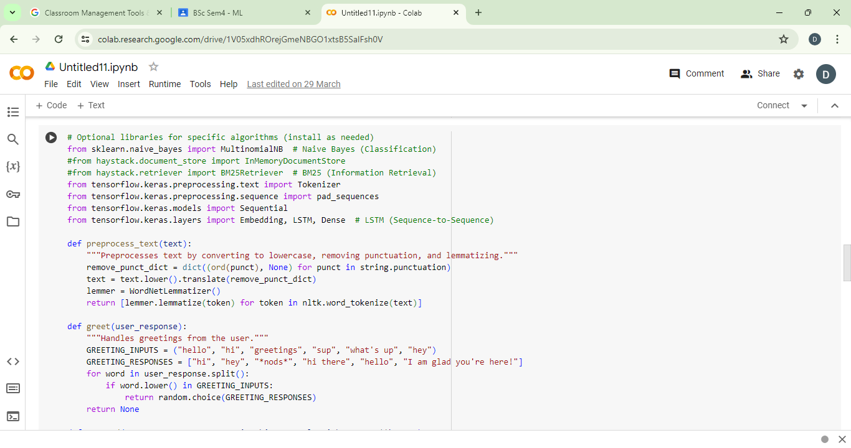

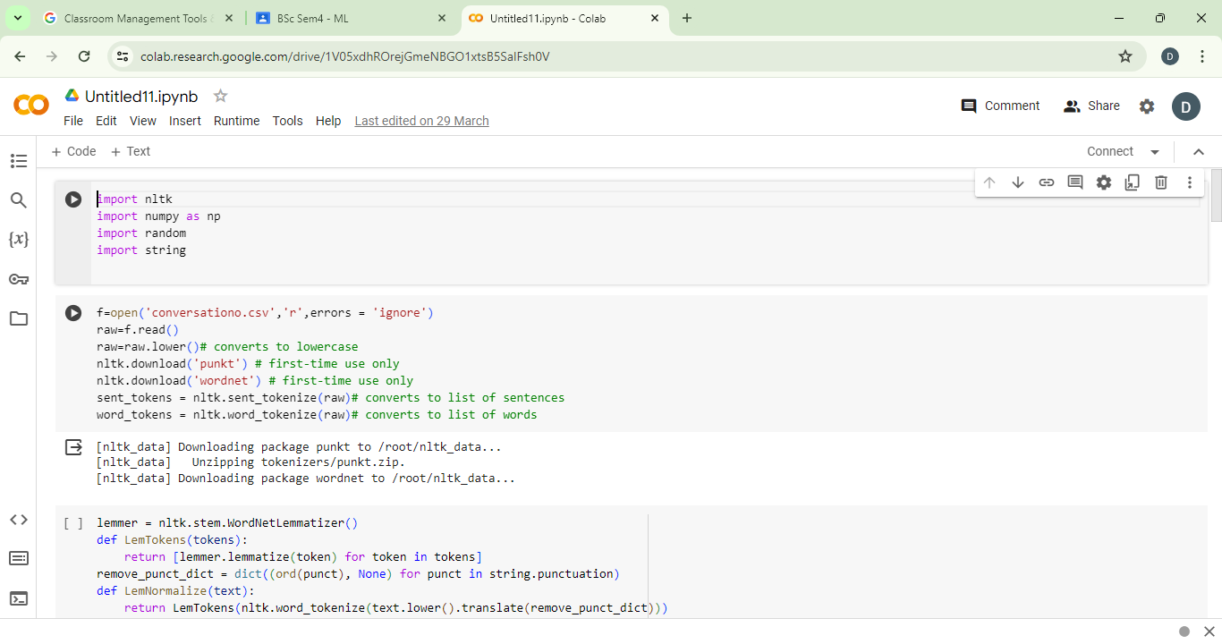

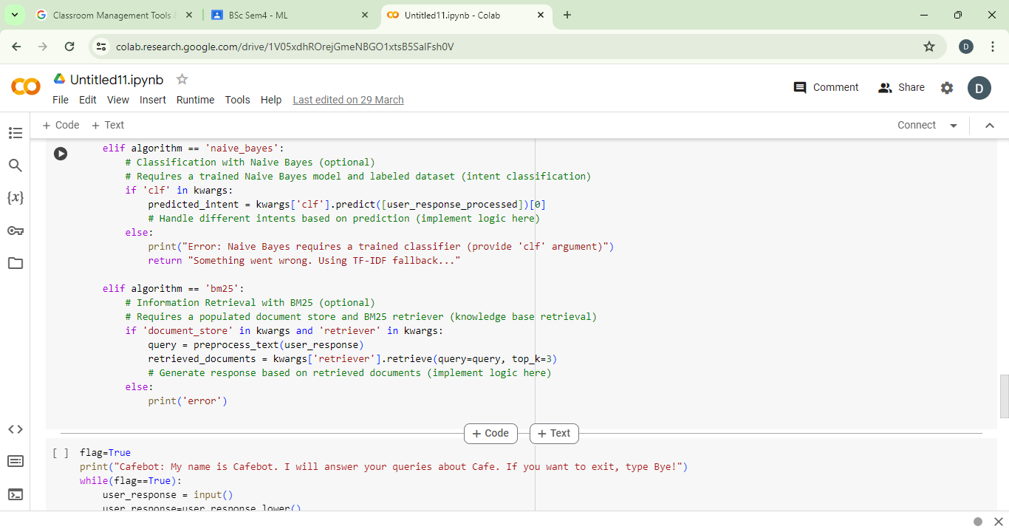

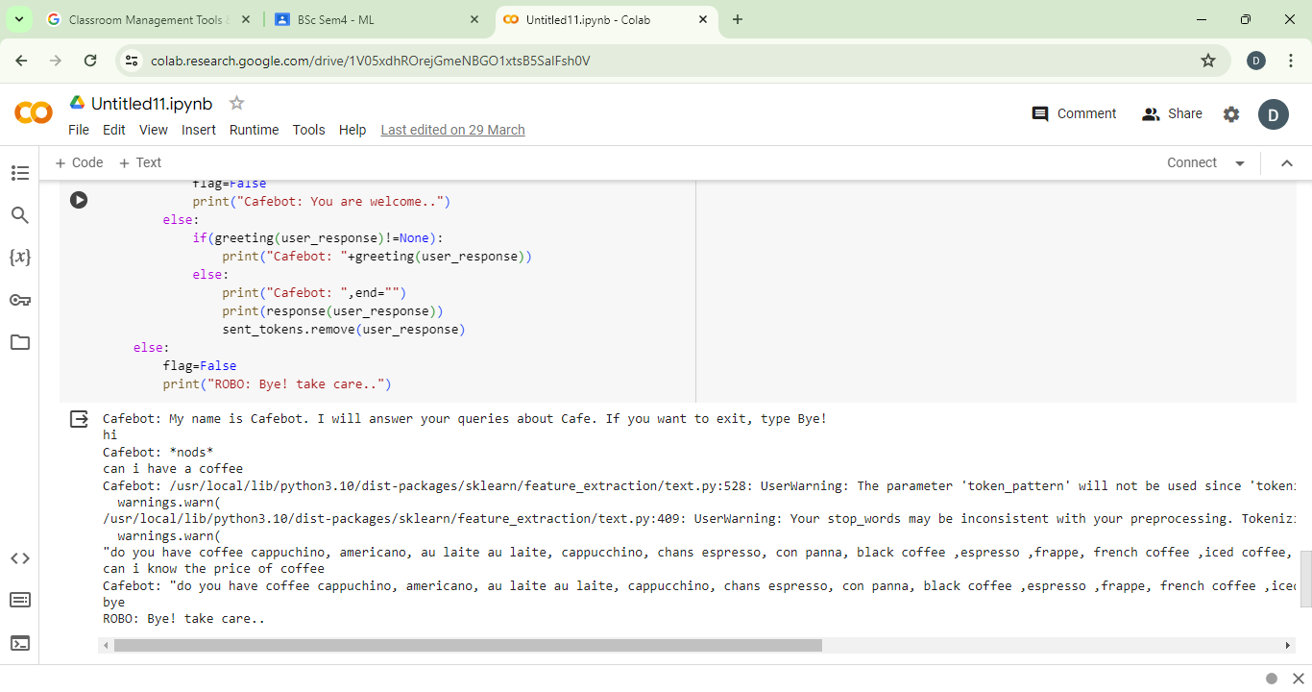

machine learning algorithms used in chatbot:

The code utilizes two main machine learning algorithms for chatbot responses:
- TF-IDF Cosine Similarity (Fallback Mechanism):
  - Function: This acts as the default response generation method when other algorithms (like Naive Bayes) are not specified or unavailable.
  - Process:
    - It converts text from conversations (including user input) into a numerical representation using TF-IDF (Term Frequency-Inverse Document Frequency). TF-IDF considers both the importance of a word in a specific document (conversation) and its overall frequency across all documents.
    - Then, it calculates the cosine similarity between the user's input and the existing conversation history represented as TF-IDF vectors. Cosine similarity measures how similar two vectors are directionally.
    - Based on the similarity score, the algorithm selects the most relevant sentence from the conversation history as the response.
- Naive Bayes:
  - Function: This is a supervised classification algorithm (requires training data). It can be used to categorize user queries based on predefined intents (e.g., greetings, cafe inquiries).
  - Implementation: (Not fully implemented in the provided code)
    - The code includes placeholder sections for training a Naive Bayes classifier (clf.fit(X_train, y_train)) but this part is not executed.
    - If a trained classifier (clf) is provided as an argument, the algorithm would categorize the user's input based on the trained model.
    - The response generation would then depend on the predicted intent. The code mentions handling greetings and cafe inquiries as separate intents, but the specific logic for handling these intents based on the prediction is not implemented.
Other Libraries:
The code also includes imports for other algorithms but they are not used in the core functionality:
- BM25 Retriever (Information Retrieval): This could be used to retrieve relevant documents from a knowledge base based on the user's query.
- LSTM (Sequence-to-Sequence): This is a neural network architecture that could be used to generate more complex and sequential responses based on the conversation history.

Answers:

1. Understand different machine learning techniques and its applications with respect to your project/case study problem statement.

Machine Learning Techniques for Interactive AI Chatbots
Interactive AI chatbots leverage various Machine Learning (ML) techniques to understand user intent, generate responses, and improve over time. Here's a breakdown of some key techniques and their applications in chatbots:
1. Natural Language Processing (NLP):
This is the foundation of any chatbot using ML. NLP techniques enable the chatbot to understand the meaning behind human language. Here are some key NLP tasks used in chatbots:
- Tokenization: Breaking down text into individual words or phrases (tokens).
- Stemming/Lemmatization: Reducing words to their base form (e.g., "running" -> "run").
- Part-of-Speech (POS) Tagging: Identifying the grammatical function of each word (e.g., noun, verb, adjective).
- Named Entity Recognition (NER): Recognizing and classifying named entities like people, locations, and organizations.
2. Supervised Learning:
This involves training ML models on labeled data to perform specific tasks. Here are common supervised learning applications in chatbots:
- Intent Classification: Classifying user queries based on their intent (e.g., asking a question, requesting a service, providing feedback). Algorithms like Support Vector Machines (SVM) or Neural Networks can be used.
- Slot Filling: Identifying and extracting specific details from user queries (e.g., location in a restaurant reservation request). Techniques like Conditional Random Fields (CRF) are commonly employed.
3. Unsupervised Learning:
While supervised learning requires labeled data, unsupervised learning can be valuable for open-ended conversations. Here's an example:
- Topic Modeling: Identifying underlying themes in conversation history to understand the broader context of user intent. Latent Dirichlet Allocation (LDA) is a popular technique for this.
4. Reinforcement Learning:
This allows chatbots to learn and improve through interaction with users. By rewarding the chatbot for informative, helpful, and engaging responses, it can continuously adapt its conversation skills.
Developing an AI Chatbot:
Here's a high-level approach to building an AI chatbot using ML:
- Data Collection: Gather a large and diverse dataset of conversation transcripts or user queries with corresponding responses.
- Preprocessing: Clean and pre-process the data using NLP techniques like tokenization and stemming.
- Model Training: Train different ML models based on your desired functionalities (e.g., intent classification, slot filling).
- Dialogue Management: Design a system to manage the conversation flow, keeping track of context and user intent across interactions.
- Integration: Integrate the ML models and dialogue management system into a chatbot framework (e.g., Rasa, Dialogflow).
- Evaluation and Improvement: Continuously evaluate the chatbot's performance and user satisfaction. Refine the training data, models, and dialogue management based on feedback.

2.Understand the importance of simple linear regression in predicting
New observations with respect to your project/case study. Can Simple Linear Regression can be used for your problem? Yes/No Explain why?

No, Simple Linear Regression cannot be effectively used for building an interactive AI chatbot. Here's why:
Simple Linear Regression Limitations:
- Focuses on predicting a single continuous variable: Chatbots deal with various tasks, including:
  - Classification: Categorizing user intent (e.g., question, request).
  - Information Retrieval: Finding relevant information based on user queries.
- Limited to linear relationships: Real-world chatbot conversations are complex and unlikely to have a strictly linear relationship between user input and desired output.
Unsuitable for Chatbot Development:
- Chatbot responses are not simply predicted values based on a single variable (user input). They involve understanding context, intent, and potentially multiple factors.
- Simple Linear Regression wouldn't be able to capture the nuances of natural language, the complexities of conversation flow, or the diverse tasks a chatbot might need to perform.
More Appropriate Techniques for Chatbots:
- Supervised Learning Algorithms:
  - Intent Classification: Classify user queries based on intent using techniques like Support Vector Machines (SVM) or Neural Networks.
  - Named Entity Recognition (NER): Identify and classify named entities using Conditional Random Fields (CRF) or Bi-directional LSTMs.
- Unsupervised Learning:
  - Topic Modeling: Identify underlying themes in conversation history using Latent Dirichlet Allocation (LDA) to understand context.
- Reinforcement Learning: Reward the chatbot for informative and engaging responses to continuously improve its conversation skills.

3.Understand the importance of Multiple linear regression in predicting new observations with respect to your project/case study. Can Multiple Linear Regression can be used for your problem? Yes/No Explain why?

Multiple Linear Regression, while a step closer, is also not ideal for building an interactive AI chatbot. Here's why:
Multiple Linear Regression Limitations:
- Focuses on predicting a single continuous variable : Similar to simple linear regression, it predicts a single numerical value based on multiple independent variables. Chatbots often deal with tasks beyond numerical prediction, like:
  - Classification: Categorizing user intent (question, request, feedback).
  - Information Retrieval: Finding relevant information based on user queries.
  - Task Automation: Completing tasks like booking appointments.
Limited to Linear Relationships:
- While it can handle multiple factors, it still assumes a linear relationship between those factors and the outcome. Conversations and user intent are rarely this linear.
Unsuitable for Core Chatbot Functionality:
- Chatbot responses are not simply predicted values based on multiple user inputs. They involve understanding complex interactions between user input, context, and the desired action.
- Multiple linear regression wouldn't be able to capture the richness of natural language, the dynamism of conversation flow, or the diverse functionalities a chatbot may require.
More Appropriate Techniques for Chatbots:
Here are some machine learning approaches that better suit chatbots:
- Supervised Learning Algorithms:
  - Intent Classification: Classify user queries based on intent using techniques like Support Vector Machines (SVM) or Neural Networks.
  - Named Entity Recognition (NER): Identify and classify named entities using Conditional Random Fields (CRF) or Bi-directional LSTMs.
  - Slot Filling: Extract specific details from user queries (e.g., location in a restaurant reservation request) using techniques like Recurrent Neural Networks (RNNs).

4.For your project definition, explain the importance of parameter estimation. Check how it affects the overall results when you change the values of different parameters.

Importance of Parameter Estimation in AI Chatbots
In building an AI chatbot with machine learning (ML), parameter estimation plays a crucial role in how well the chatbot understands user intent, generates responses, and ultimately performs its tasks. Here's why it's important:
1. Learning from Data:
ML algorithms learn by identifying patterns and relationships within data. These patterns are captured through mathematical functions with adjustable parameters. The process of finding the optimal values for these parameters is called parameter estimation.
2. Optimizing Performance:
The effectiveness of an ML model heavily depends on the chosen parameters and their values. By adjusting these parameters through estimation techniques, we can fine-tune the model to better fit the training data and generalize well to unseen examples (user queries).
3. Balancing Trade-offs:
ML algorithms often involve trade-offs. For instance, increasing model complexity might improve accuracy on training data but could lead to overfitting (failing to generalize well). Parameter estimation helps us find the sweet spot between accuracy and generalization.
Examples of Parameters and their Impact:
Here are some common parameters in chatbot development and how changing their values can affect performance:
- Regularization Parameters (e.g., L1/L2 penalty in Logistic Regression):
  - Higher values can prevent overfitting but might decrease model flexibility.
  - Lower values can lead to overfitting but might capture more complex relationships.
- Learning Rate (e.g., in Gradient Descent Optimization):
  - Higher values can lead to faster learning but might cause the model to miss the optimal solution (get stuck in local minima).
  - Lower values can lead to slower learning but might allow for more precise convergence.
- Number of Hidden Layers/Neurons in Neural Networks:
  - More layers/neurons can capture complex relationships but increase training time and risk overfitting.
  - Fewer layers/neurons might be faster to train but might not capture the necessary complexity.
Techniques for Parameter Estimation:
Here are some common techniques for parameter estimation in ML:
- Gradient Descent Optimization: An iterative algorithm that adjusts parameters based on the error between the model's predictions and the actual data.
- Grid Search or Random Search: Systematically trying different combinations of parameter values to identify the best performing set.
- Bayesian Optimization: A probabilistic approach that efficiently explores the parameter space to find optimal values.
Evaluating the Impact of Parameter Changes:
To assess the impact of parameter changes on chatbot performance, you can use techniques like:
- Cross-validation: Dividing the data into training, validation, and test sets. Train the model on the training set with different parameter configurations, evaluate its performance on the validation set, and choose the parameters that lead to the best performance on the unseen test set.
- Monitoring Metrics: Track key metrics like accuracy, precision, recall, F1-score, and user satisfaction to understand how parameter changes affect the chatbot's ability to understand user intent and generate helpful responses.
Conclusion
By effectively utilizing parameter estimation techniques, you can build a more robust and adaptable AI chatbot. Experimentation with different parameter values and careful evaluation are crucial for optimizing chatbot performance and achieving the desired level of user interaction and task completion.

5.Compare different Machine Learning algorithms used for your project/case through evaluation metrics. Show which ML algorithm works best for your problem.

When building an interactive AI chatbot, several machine learning algorithms can be employed for various functionalities. Here's a comparison of some common algorithms and evaluation metrics
Choosing the Best Algorithm:
The best ML algorithm for your chatbot depends on specific functionalities and the nature of your data. Here are some general guidelines:
- For Intent Classification: Start with SVMs or Naive Bayes for simpler tasks. For complex classification or sequential data, consider RNNs.
- For Slot Filling: RNNs are a good choice due to their ability to handle sequential information in sentences.
- For Topic Modeling: LDA is a popular option to understand underlying themes in conversations.
- For Dialogue Management: Reinforcement Learning offers flexibility and adaptation based on user interaction.
Evaluation and Refinement:
- Use the evaluation metrics mentioned above to compare the performance of different algorithms on your training and testing data.
- Consider factors like accuracy, efficiency, and interpretability when making your decision.
- Fine-tune the chosen algorithm's parameters through techniques like parameter estimation (e.g., Grid Search) to optimize performance.
Additional Considerations:
- Hybrid Approaches: Combining multiple algorithms can leverage the strengths of each. For instance, you might use an SVM for initial intent classification and then an RNN for more nuanced slot filling within the classified intent.
- Ensemble Methods: Combining predictions from multiple models can sometimes lead to better overall performance.
By carefully comparing different algorithms, evaluating their performance on your specific data, and considering the functionalities you want your chatbot to possess, you can select the most suitable ML approach to build an effective and engaging interactive AI chatbot.

